Cold Call Course
Cold Calls to
President’s Club
The ultimate step-by-step program to master the phones: Talk tracks, real cold call reviews, and accountability challenges to get you booking meetings today.
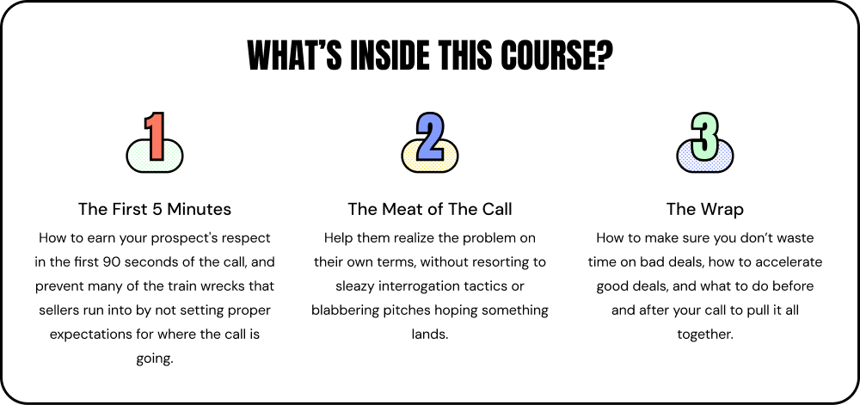



Preview Intro & Section 1 of the course for free

